**Basic Electronics**

**Course Code GE101**

**Lab 5 Manual**



**Series Circuits**

**Department of Computer Science**

**University of Central Punjab**

**Objective:**

* To learn to mount the resistive series circuit in breadboard.
* To learn to measure resistors in series, current in series circuit, voltage in series circuit, and power in series circuit.
* Practical verification of voltage divider rule.
* Verification of Kirchhoff’s circuit law on Tinker cad.
* Building series resistive circuit on circuit maker.

**Equipment:**

* Resistors
* Breadboard
* DMM

**Outcome:**

* After this lab, students will be able to mount the resistive series circuit in breadboard.
* Students will know how to use it to measure resistors in series, current in series circuit, voltage in series circuit, voltage in series, and power in series circuit.
* Students will know Practical verification of voltage divider rule.
* Students will know Verification of Kirchhoff’s circuit law on Tinker cad.

**Resistors in Series:**

When connected in series, resistors form a “string” in which there is only one path for current.

After completing this section, you should be able to

* Identify a series resistive circuit.
* Translate a physical arrangement of resistors into a schematic.

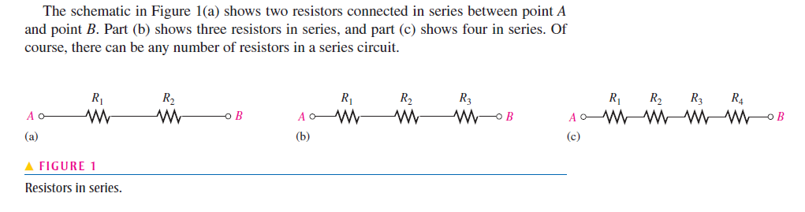

When a voltage source is connected between point *A* and *B*, the only way for current to get from one point to the other in any of the connections of Figure 1 is to go through each of the resistors. The following statement describes a series circuit:

**A series circuit provides only one path for current between two points so that the current is the same through each series resistor.**

In an actual circuit diagram, a series circuit may not always be as easy to visually identify as those in Figure 1. For example, Figure 2 shows series resistors drawn in other ways with voltage applied. Remember, if there is only one current path between two points, the resistors between those two points are in series, no matter how they appear in a diagram.

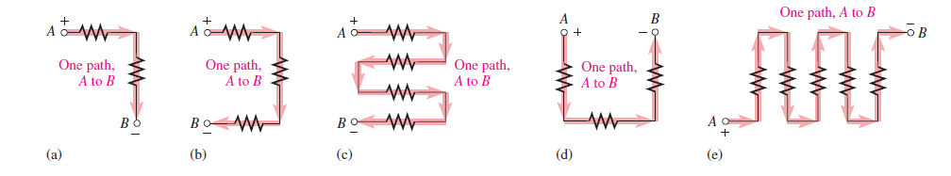

**Example:**

Suppose that there are five resistors positioned on a breadboard as shown in Figure 3.

Wire them together in series so that, starting from the positive (_) terminal, is first, *R*2 is second, *R*3 is third, and so on. Draw a schematic showing this connection.

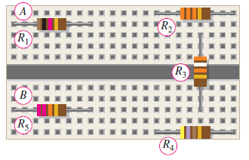

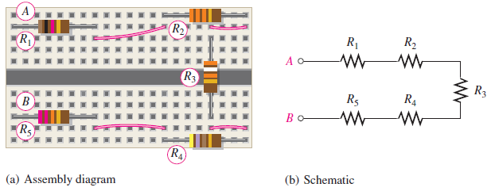

**Resistors in Series Circuit:**

When resistors are connected in series, the resistor values add because each resistor offers opposition to the current in direct proportion to its resistance. A greater number of resistors connected in series creates more opposition to current. More opposition to current implies a higher value of resistance. Thus, every time a resistor is added in series, the total resistance increases.

Figure illustrates how series resistances add to increase the total resistance. Part (a) has a 10 Ω single resistor. Part (b) shows 10Ω another resistor connected in series with the first one, making a total resistance of 20Ω. If a third 10Ω resistor is connected in series with the first two, as shown in part (c), the total resistance becomes 30 Ω.

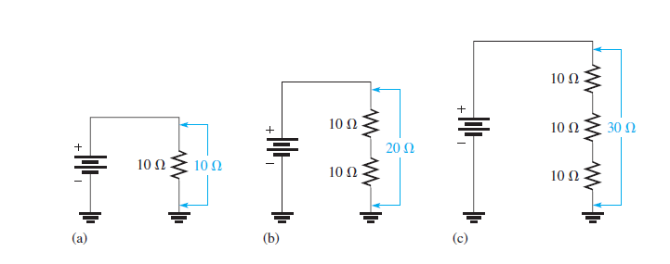

**Series Resistors Formula:**

For any number of individual resistors connected in series, the total resistance is the sum of each of the individual values.



Where is the total resistance and is the last resistor in the series string (*n* can be any positive integer equal to the number of resistors in series). For example, if there are four resistors in series (n=4) the total resistance formula is



If there are six resistors in series the total resistance formula is:



**Current in Series circuit:**

The current is the same through all points in a series circuit. The current through each resistor in a series circuit is the same as the current through all the other resistors that are in series with it.

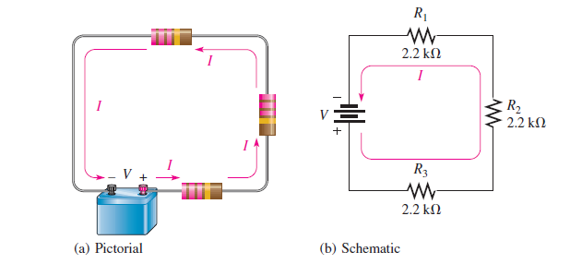

Let’s assume that the battery in Figure below supplies 1.82 mA of current to the series resistance.

There are 1.82 mA of current out of the battery’s positive terminal. When ammeters are connected at several points in the circuit, as shown in Figure 14, each meter reads 1.82 mA.

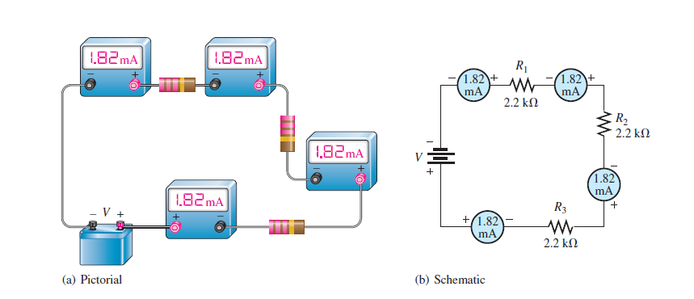

The following are key points to remember when you analyse series circuits:

**1.** Current through any of the series resistors is the same as the total current.

**2.** If you know the total applied voltage and the total resistance, you can determine the total current by Ohm’s law.



**3.** If you know the voltage drop across one of the series resistors you can determine the total current by Ohm’s law.

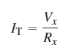

**4.** If you know the total current, you can find the voltage drop across any of the series resistors by Ohm’s law.



**5.** The polarity of a voltage drop across a resistor is positive at the end of the resistor that is closest to the positive terminal of the voltage source.

**6.** The current through a resistor is defined to be in a direction from the positive end of the resistor to the negative end.

**7.** An open in a series circuit prevents current; and, therefore, there is zero voltage drop across each series resistor. The total voltage appears across the points between which there is an open.

Now let’s look at several examples that use Ohm’s law for series circuit analysis.

**Example:**

Find the current in the circuit of Figure 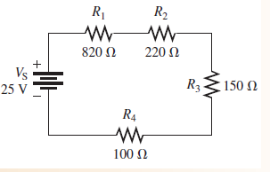

**Solution:**

The current is determined by the source voltage and the total resistance. First, calculate the total resistance.



Next, use Ohm’s law to calculate the current. where is the total voltage and I is the total current.

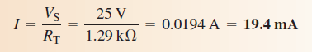

Remember, the same current exists at all points in the circuit. Thus, each resistor has 19.4 mA through it.

**Voltage in Series Circuit:**

When two or more voltage sources are in series, the total voltage is equal to the algebraic sum of the individual source voltages. The algebraic sum means that the polarities of the sources must be included when the sources are combined in series. Sources with opposite polarities have voltages with opposite signs.



When the voltage sources are all in the same direction in terms of their polarities, as in

Figure (a), all of the voltages have the same sign when added; there is a total of 4.5 V from terminal *A* to terminal *B* with *A* more positive than *B.*

The voltage has a double subscript, *AB,* to indicate that it is the voltage at point *A* with respect to point *B.*



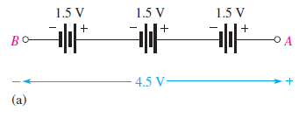

In Figure (b), the middle voltage source is opposite to the other two; so its voltage has an opposite sign when added to the others. For this case the total voltage from *A* to *B* is

Terminal *A* is 1.5 V more positive than terminal *B.*

**

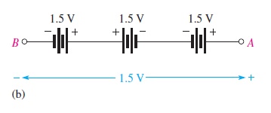

A familiar example of voltage sources in series is the flashlight. When you put two

1.5 V batteries in your flashlight, they are connected in series, giving a total of 3 V. When connecting batteries or other voltage sources in series to increase the total voltage, always connect from the positive ( ) terminal of one to the negative (-) terminal of another. Such a connection is illustrated in Figure

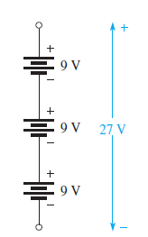

Many circuits use positive and negative supply voltages. A dual-power supply will normally have two independent outputs such as those shown in Figure 26. Show how to connect the two 12 V outputs from the power supply so that there is both a positive and a negative output.

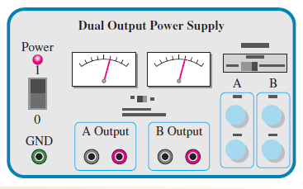 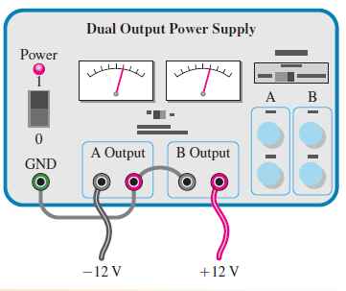

**Kirchhoff’s Voltage Circuit:**

In an electric circuit, the voltages across the resistors (voltage drops) *always* have polarities opposite to the source voltage polarity. For example, in Figure, follow a clockwise loop around the circuit. Note that the source polarity is minus-to-plus and each voltage drop is plus-to-minus. The voltage drops across resistors are designated as *V*1, *V*2, and so on.

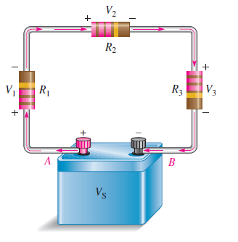

In Figure, the current is out of the positive side of the source and through the resistors as the arrows indicate. The current is into the positive side of each resistor and out the negative side. The drop in energy level across a resistor creates a potential difference, or voltage drop, with a plus-to-minus polarity in the direction of the current.

The voltage from point *A* to point *B* in the circuit of Figure is the source voltage,

Also, the voltage from *A* to *B* is the sum of the series resistor voltage drops. Therefore, the source voltage is equal to the sum of the three voltage drops, as stated by **Kirchhoff’s** **voltage law**.

**The sum of all the voltage drops around a single closed path in a circuit is equal to the total source voltage in that loop.**

Kirchhoff’s voltage law applied to a series circuit is illustrated in Figure below. For this case, Kirchhoff’s voltage law can be expressed by Equation.



Where the subscript *n* represents the number of voltage drops.

If all the voltage drops around a closed path are added and then this total is subtracted from the source voltage, the result is zero. This result occurs because the sum of the voltage drops always equals the source voltage.

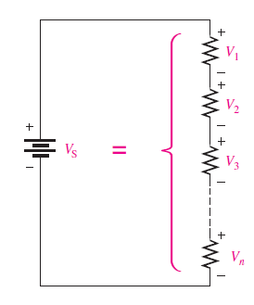

**The algebraic sum of all the voltages (both source and drops) around a single closed path is zero.**

Therefore, another way of expressing Kirchhoff’s voltage law in equation form is



You can verify Kirchhoff’s voltage law by connecting a circuit and measuring each resistor voltage and the source voltage as illustrated in Figure below. When the resistor voltages are added together, their sum will equal the source voltage. Any number of resistors can be added.

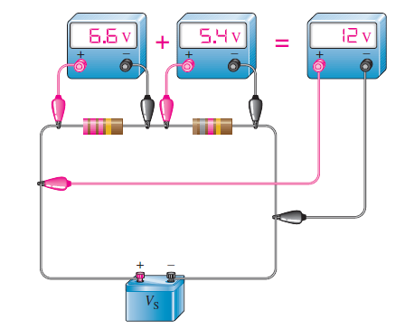

**Voltage divider in series circuit:**

A circuit consisting of a series string of resistors connected to a voltage source acts as a voltage divider. Figure shows a circuit with two resistors in series, although there can be any number. There are two voltage drops across the resistors: one across *R*1 and one

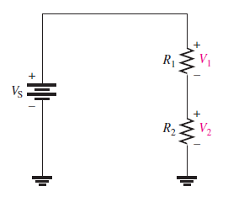

across these voltage drops are and respectively, as indicated in the schematic.

Since each resistor has the same current, the voltage drops are proportional to the resistance values. For example, if the value of is twice that of then the value of is twice that of

The total voltage drop around a single closed path divides among the series resistors in amounts directly proportional to the resistance values. For example, in Figure 36, if is 10 V, is and is then is one-third the total voltage, or 3.33 V, because is one-third the total resistance of Likewise, is two-thirds or 6.67 V.

**Voltage-Divider Formula:**

With a few calculations, you can develop a formula for determining how the voltages divide among series resistors. Assume a circuit with *n* resistors in series as shown in Figure below: 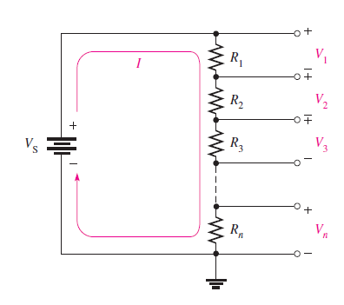

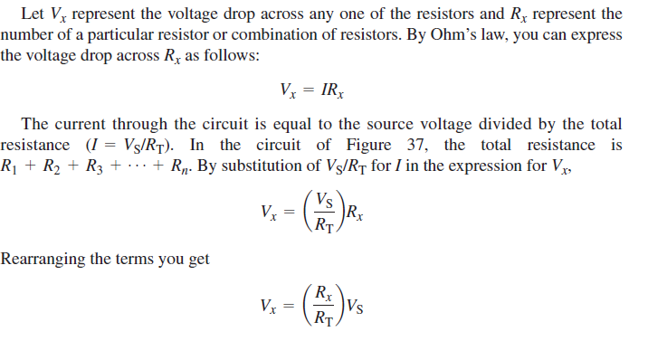

**A Potentiometer as an Adjustable Voltage Divider:**

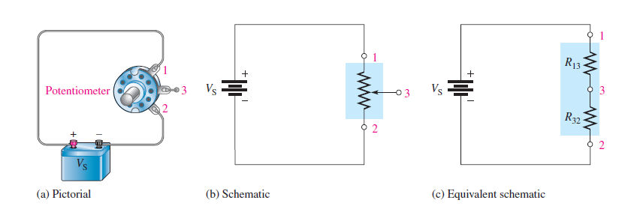

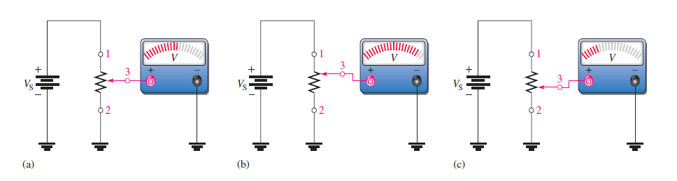

**Power in series circuit:**

The total amount of power in a series resistive circuit is equal to the sum of the powers in each resistor in series.



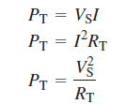

**TASK TO PERFORM**

**Resistors in series:**

**Task 1**

**Connect the resistors in Figure in series, and determine the total resistance, from the colour codes**. **Build your circuit on tinker cad and circuit maker.**

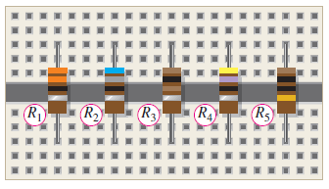

**Task 2**

**What is the total resistance (*R*T) in the circuit of Figure and connect the resistors on breadboard.**

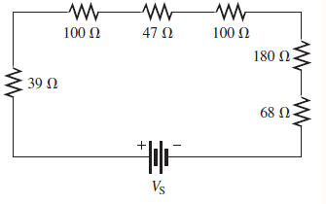

**Task 3**

**Connect the resistors in Figure in series, and determine the total resistance, from the color codes. Implement the circuit on tinker cad and circuit maker:**

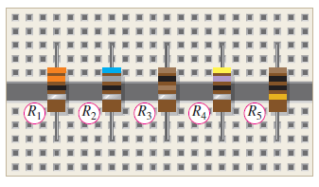

**Current in series:**

**Task 4**

**The current in the circuit of Figure is 1 mA. For this amount of current, what must the source voltage *V*S be? Build the circuit on circuit maker.**

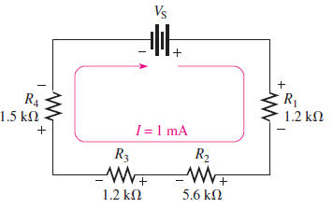

**Task 5**

**Calculate the voltage across each resistor in Figure 19, and find the value of *V*S. To what maximum value can *V*S be raised if the current is to be limited to 5 mA? Build the circuit on tinker cad and circuit maker.**

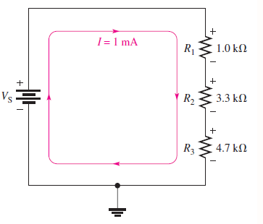

**Voltage in Series:**

**Task 6**

**What is the total source voltage (*V*S(tot)) in Figure. Build circuit on circuit maker.**

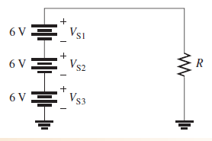

**Kirchhoff’s Voltage circuit:**

**Task 7**

**Determine the source voltage *V*S in Figure where the two voltage drops are given. There is no voltage drop across the fuse. Also build circuit in tinker cad and verify the answer.**

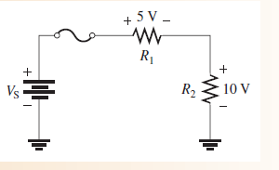

**Task 8**

**Find the value of *R*4. Also build the circuit in tinker cad to verify the Kirchhoff’s circuit law.**

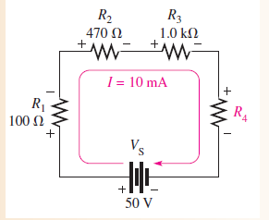

**Voltage Divider in Series:**

**Task 9**

**Determine V1 (the voltage across R1) and V2 (the voltage across R2) in the voltage divider in Figure. Build the circuit on tinker cad and circuit maker to verify.**

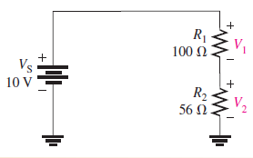

**Power in Series Circuit:**

**Task 10**

**Determine the total amount of power in the series circuit in Figure. Implement on tinker cad and circuit maker to verify.**

